**NYASHA SIMANGO H150319N LAB ASSGNMENT**

**Lab Assignment:**

**Aim**

Write a Python program to create a Caesar encryption.

**Methodology:**

Using Jupyter Notebook python version 2.7:

1. Click File and Create a new file
2. Write the code to execute our aim
3. Click file then save
4. Click run

**Output:**

**Encryption**

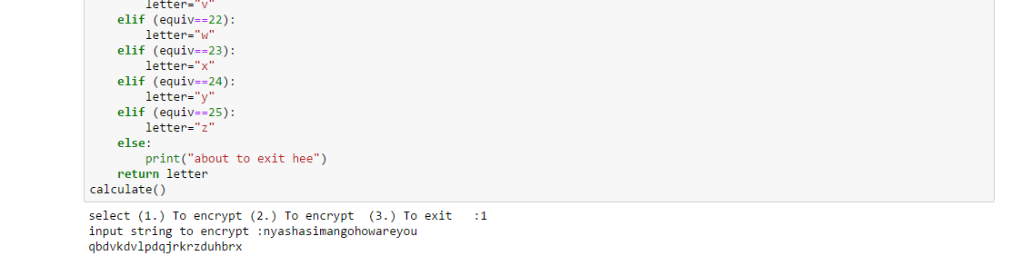

**Decryption**

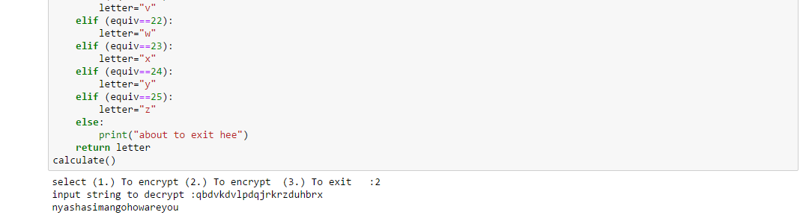

**Source Code**

#Function to encrypt

def encrypt(a,b):

h=int(a)

i=int(b)

result=((i+h)%26)

return result

#Function to decrypt

def decrypt(a,b):

h=int(a)

i=int(b)

result=((i-h)%26)

return result

#Function to start execution

def calculate():

x=3

v= int(input("select (1.) To encrypt (2.) To encrypt (3.) To exit :"))

if(v==1):

z=input("input string to encrypt :")

for words in z:

g=convert(words)

answer=encrypt(x,g)

final=converts(answer)

print(final,end='')

elif(v==2):

z=input("input string to decrypt :")

for words in z:

g=convert(words)

answer=decrypt(x,g)

final=converts(answer)

print(final,end='')

else:

print("about to exit")

#Function to convert a letter to int equiv

def convert(letter):

if (letter=="a" or letter=="A" ):

equiv=0

elif (letter=="b" or letter=="B" ):

equiv=1

elif (letter=="c" or letter=="C" ):

equiv=2

elif (letter=="d" or letter=="D" ):

equiv=3

elif (letter=="e" or letter=="E" ):

equiv=4

elif (letter=="f" or letter=="F" ):

equiv=5

elif (letter=="g" or letter=="G" ):

equiv=6

elif (letter=="h" or letter=="H" ):

equiv=7

elif (letter=="i" or letter=="I" ):

equiv=8

elif (letter=="j" or letter=="J" ):

equiv=9

elif (letter=="k" or letter=="K" ):

equiv=10

elif (letter=="l" or letter=="L" ):

equiv=11

elif (letter=="m" or letter=="M" ):

equiv=12

elif (letter=="n" or letter=="N" ):

equiv=13

elif (letter=="o" or letter=="O" ):

equiv=14

elif (letter=="p" or letter=="P" ):

equiv=15

elif (letter=="q" or letter=="Q" ):

equiv=16

elif (letter=="r" or letter=="R" ):

equiv=17

elif (letter=="s" or letter=="S" ):

equiv=18

elif (letter=="t" or letter=="T" ):

equiv=19

elif (letter=="u" or letter=="U" ):

equiv=20

elif (letter=="v" or letter=="V" ):

equiv=21

elif (letter=="w" or letter=="W" ):

equiv=22

elif (letter=="x" or letter=="X" ):

equiv=23

elif (letter=="y" or letter=="Y" ):

equiv=24

elif (letter=="z" or letter=="Z" ):

equiv=25

else:

print("letter not found in the Z26 universe")

return equiv

#Function to convert an int to letter equiv

def converts(equiv):

if (equiv==0):

letter="a"

elif (equiv==1):

letter="b"

elif (equiv==2):

letter="c"

elif (equiv==3):

letter="d"

elif (equiv==4):

letter="e"

elif (equiv==5):

letter="f"

elif (equiv==6):

letter="g"

elif (equiv==7):

letter="h"

elif (equiv==8):

letter="i"

elif (equiv==9):

letter="j"

elif (equiv==10):

letter="k"

elif (equiv==11):

letter="l"

elif (equiv==12):

letter="m"

elif (equiv==13):

letter="n"

elif (equiv==14):

letter="o"

elif (equiv==15):

letter="p"

elif (equiv==16):

letter="q"

elif (equiv==17):

letter="r"

elif (equiv==18):

letter="s"

elif (equiv==19):

letter="t"

elif (equiv==20):

letter="u"

elif (equiv==21):

letter="v"

elif (equiv==22):

letter="w"

elif (equiv==23):

letter="x"

elif (equiv==24):

letter="y"

elif (equiv==25):

letter="z"

else:

print("about to exit hee")

return letter

calculate()

**Conclusion**

The program could take could encrypt and decrypt a string and return the same result.